Call for AAPPS-DPP Young researcher award 2026
2026.02.01AAPPS-DPP BoD

AAPPS-DPP recognizes young research scientists not more than 40 by AAPPS-DPP young research award since 2016. We will select 2026 winners along with our annual conference during Sep. 21-26, 2026. See past recipients at http://aappsdpp.org/AAPPSDPPF/awardtable.html. A maximum of one award may be attributed for each of the seven sub-disciplines of the AAPPS-DPP. These sub-disciplines are: Fundamental, Basic, Applied, Laser, Space and Geomagnetism, Solar and Astrophysics, and Magnetic Fusion. When appropriate, the Committee may consider the nominee in a sub-discipline different from the originally nominated one. Selection committee will be formed under the chairmanship of Prof. R. Ganesh. Nomination shall be sent to DPP CEO (aapps.dpp.ceo@gmail.com) during March 1 – May 31.

- Eligibility: AAPPS-DPP member who, by the date of nomination deadline, is 40 years old (and not reach 41) or younger and 31 years or more. For the two significant papers, at least one should have a primary AAPPS affiliation so that candidate’s main body of works should have affiliation from AAPPS region*. Candidate must submit contributed (or plenary/invited if selected) abstract by its deadline (May 31). If not, he/she will be deleted from the candidate list.
- Qualification: Played a leading role in making a significant research contribution(s) to plasma physics.
- Nomination package: Use attached nomination form for the nomination. No self-nomination is allowed.
Section 1 Nomination and Undertaking by Nominee: Fill in all requested details in Section 1 of the “Nomination Form”. Nominator must be an AAPPS-DPP member. The nominator’s nomination letter and seconding letters (<3pages) should be attached as appendix.
Section 2 Biographical details of nominee: Fill in all requested details in Section 2 of the “Nomination Form”. No separate CV is needed. The nominee should provide his/her own statement of why he/she deems deserving the award.
Section 3: Scientific contributions of the Nominee: Fill in all requested details in Section 3 of the “Nomination Form”. Attach copies of nominee’s two best papers as appendix. Please provide links to Web of Science (WoS) and Google Scholar citation records. Section 4: Full list of publication (including books): List should include WoS citation number for each paper (for possible papers recorded in WoS) and Google Scholar citations (including Books). Use Web of Science (https://access.clarivate.com/login?app=wos). Include information on the journal impact factor for important papers.
Attachments: Two significant publications in PDF format: For each listed major publication, the nominator should indicate the role(s) played by the nominee and, if possible, the relative weight of his/her contribution. For age verification, relevant page of copy of passport may be requested.
- Award ceremony and talk: Committee will select at maximum one winner from each sub-discipline. Winner will receive US$500 and a certificate. The recipients must participate and present his/her work in order to receive the award (unless due to some justifiable reasons).
*: AAPPS region shown in Green. EPS member society’s regions (Turkey, Israel, Geogia) will be excluded.
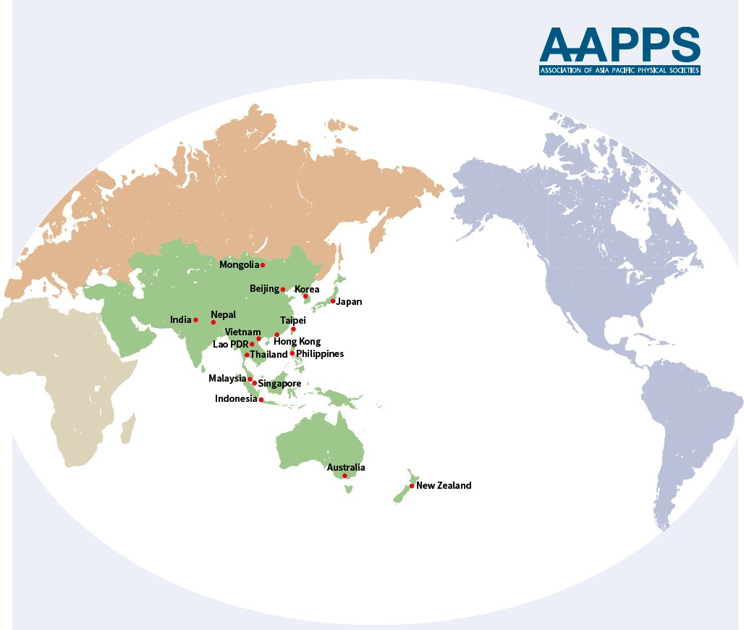

2026 Nomination form for the AAPPS-DPP Young Researcher Award

Note: Please carefully prepare all parts of the nomination form, including Section 1- 4. After completing and signing the form, please make the pdf of the file and submit the pdf files only. Please arrange Section 2-4 starting from new pages.

Section 1: Nomination and Undertaking by Nominee

The Nominee
Name
Affiliation
Membership ID number
No self-nomination

The Nominator*
Name
Affiliation
Membership ID number
Nomination letter should be limited to maximum of three pages.

Seconding persons*
Name #1
Affiliation
Name #2
Affiliation
*Not limited to AAPPS-DPP members but must be from well-known experts in the field. Each seconding letter should be limited to maximum of three pages, signed and on the letterhead of the expert seconding the nomination.

Proposed citation for the Award (less than 50 words):

Signature of Nominator: Date:

Undertaking by Nominee
I, , hereby agree that if selected for the AAPPS-DPP Young Researcher Award, I will participate and present a talk at the AAPPS-DPP2026 annual conference.

Date: Signature of Nominee

For Office use
Date of Receipt:
Whether considered earlier: Yes/No If Yes, years of consideration:

Section 2: Biographical Details of Nominee

# | Item | Description
1 | Full name:
2 | Title/current position:
3 | Affiliation:
4 | e-mail ID:
5 | Date and place of birth:
6 | Age at date of nomination deadline:
7 | Nationality: | Present: |  | Past (if any):
8 | Education : PhD Master Bachelor | Year | Degree | University/Institution
9 | Career History (in reverse chronological order) | e.g.*  - Associate Professor, University of XYZ, PQR (2008 – 2002)  - Assistant Professor, University of XYZ, PQR (2002 – 1996)
10 | Journal Services: (Editorships and Editorial Board Memberships) | e.g.*  - Associate Editor of RMPP  - Associate Editor of XYZ  - Editorial Board Member of XYZ
11 | Visiting Positions: | e.g.*  - Guest Professor, Kyoto University (1999-2002)  - Visiting Professor, Chinese Academy of Science (2010-2012)
12 | Society Services: | e.g.*  - Council member of XYZ, (2020-present)  - XYZ committee member, US National Academy of Science (2014-2016)
13 | Memberships: | e.g.*  - Member, Chinese Physical Society  - Member, Division of Plasma Physics, AAPPS
14 | PhD thesis advisor if any: | Name, Affiliation, title, year
14 | PhD thesis advisor if any: | 1.  2.
15 | List of past scientific awards/recognitions of nominee  e.g.*  - Elected member, TWAS (year)  - XXX Medal, Australian Institute of Physics (year)
16 | Personal or Institutional web page (if any)
17 | Nominee’s statement of why he/she deems deserving the award. (<200 words).
*Please replace light grey text by relevant information.

Section 3: Scientific Contributions of the Nominee

1 | Critical summary of the most seminal/original contributions of the nominee in plasma physics by the nominator (<200 words).
2 | First best paper and description of its seminal/original contribution to plasma physics (each<300 words).  [In case of multi-authored publications the specific contribution of the nominee should be clearly given.]
2 | [1] Kazunori Takahashi,Trevor Lafleur,Christine Charles,Peter Alexander,and Rod W. Boswell1, Electron Diamagnetic Effect on Axial Force in an Expanding Plasma: Experiments and Theory, Phys. Rev. Lett 107(2011)235001
3 | Second best paper and description of its seminal/original contribution to plasma physics (each<300 words).  [In case of multi-authored publications the specific contribution of the nominee should be clearly given.]
3 | [2] Kazunori Takahashi, Christine Charles, and Rod W. Boswell, Approaching the Theoretical Limit of Diamagnetic-Induced Momentum in a Rapidly Diverging Magnetic Nozzle, Phys. Rev. Lett 110(2013)195003
4 | Nominee’ Publication  (total numbers only, details later) | Number of Refereed Journal Papers
4 | Nominee’ Publication  (total numbers only, details later) | Number of Books
5 | Nominee’s Citation Summary (Inc. books) | WoS Citation Count: | WoS H-index:
5 | Nominee’s Citation Summary (Inc. books) | Google Scholar Citations: | Google Scholar H-index:
6 | Link to Nominee’s | Copy links below:* [example is 2018 laureate and replace to nominee’s link]
6 | Google Scholar Web of Science | https://scholar.google.com/citations?user=qwN3bpIAAAAJ&hl=en https://www.webofscience.com/wos/author/record/1655688
*Please replace light grey text by relevant information.

Section 4: Full list of publications (including books)
- Format of entry: In order of higher citation number in Google scholar. Each paper in order of Authors, Paper/Book/Book Chapters title, Journal/Publisher name, volume, pages, and year. Refer sample.
- For each entry, all co-authors should be listed. We will use it to check COI with Selection Committee members.
- Nominee’s name should be in bold. Put # mark if the nominee is the corresponding author or the co-first author.
- For important 2 papers, Highlight the cell with light yellow colour for five best papers. Please mention the impact factor (IF) and the DOI for these important papers.
# | Paper (authors, paper title, journal volume, year, page)  / Book (authors, book title, publisher, year) with candidate name in bold | WoS cites | Google cites
1 | A B First, C D Second, E Third#, and F G Fourth, Physical Review Letters xx, zz (YYY). IF – 7.6, DOI: https/… | 50 | 70
2 | A B First, E Third, C D Second and F G Fourth, Journal of Astro Plasma 37, 3337 (2021). | 30 | 45
3
4
5
6
7
8
9
10
11
12
13
14
15
16
17
18
19
20
21
22
23
24
25
26
27
28
29
30
31
32
33
34
35
36
37
38
39
40
41
42
43
44
45
46
47
48
49
50
51
52
53
54
55
56
57
58
59
60
61
Extend or delete the number of rows, as needed, to present the full list of publications. Replace the grey sample text with actual information of the nominee.

Attachments:
  - Nominator’s nomination letter of less than 3 pages.
  - Seconding letters from two leading experts in the field of less than 3 pages each. The experts need not be AAPPS-DPP members.
  - Copy of the 2 best papers of the nominee as listed above.
  - For age verification, relevant page of copy of passport may be requested.
The completed form with the above attachments should be submitted by email to the DPP CEO at (aapps.dpp.ceo@gmail.com) in one pdf file before the deadline stipulated in the announcement.

